**Matlab2017a - Adams2012 Co-Simulation Documentation**

Notice:

1. Must to make sure ADMAS and Matlab files are in the same folder with same directory;

2. Must be sure ADAMS contains file ‘**adams_plant.mexw64**’ in the following path:

C:\MSC.Software\Adams_x64\2012\controls\win64

3. Must be sure all the variables are named with ‘Full Name’, such as, ‘**.RCB_CoSim.Variable**’, otherwise, the ADAMS will display error ‘No model has been defined’;

**Part I. Procedure for ADAMS**

*Step 1: Set the model in ADAMS*

a. Prepare ‘Model.x_t’ file and import into ADAMS2012;

b. Add properties, such as, Mass, Joints, and Motions, or Markers, etc.

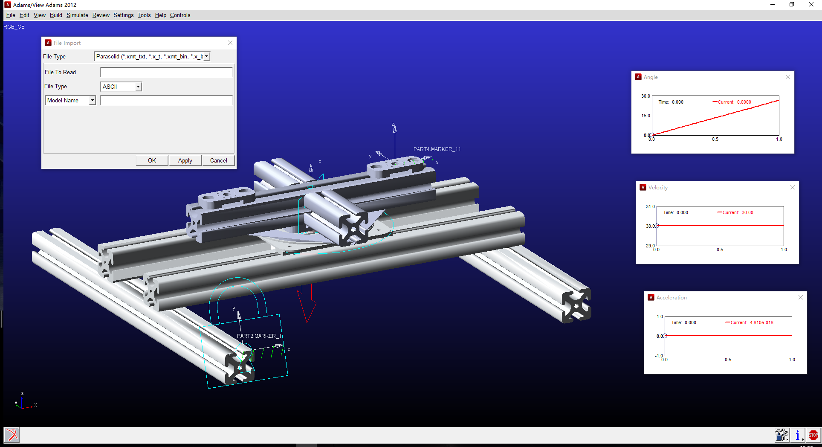

*Step 2: Set ‘Inputs’ and ‘Outputs’ variables*

a. **Build – System Elements – State Variable – New**;

b. Create all ‘**Inputs**’ variables, such as, inputs: [q0, q11, q12, q14, q21, q22, q23];

Don’t forget to add “**Motion**” on the actuated joints and the ‘**Function (time)**’ as:

*VARVAL(.modelname.variablename)*

c. Create all ‘**Outputs**’ variables, which could be a ‘measure’ we build in previous step;

* Open the variable ‘**State Elements** - **Variable**’,
* Select ‘**Getting Object Data – Measure – Runtime Measure – Guess - Variable**’,
* Press ‘**Insert Object Name**’ (Then, choose ‘**Full Name**’ is Very Important!!)
* Press ‘Ok’

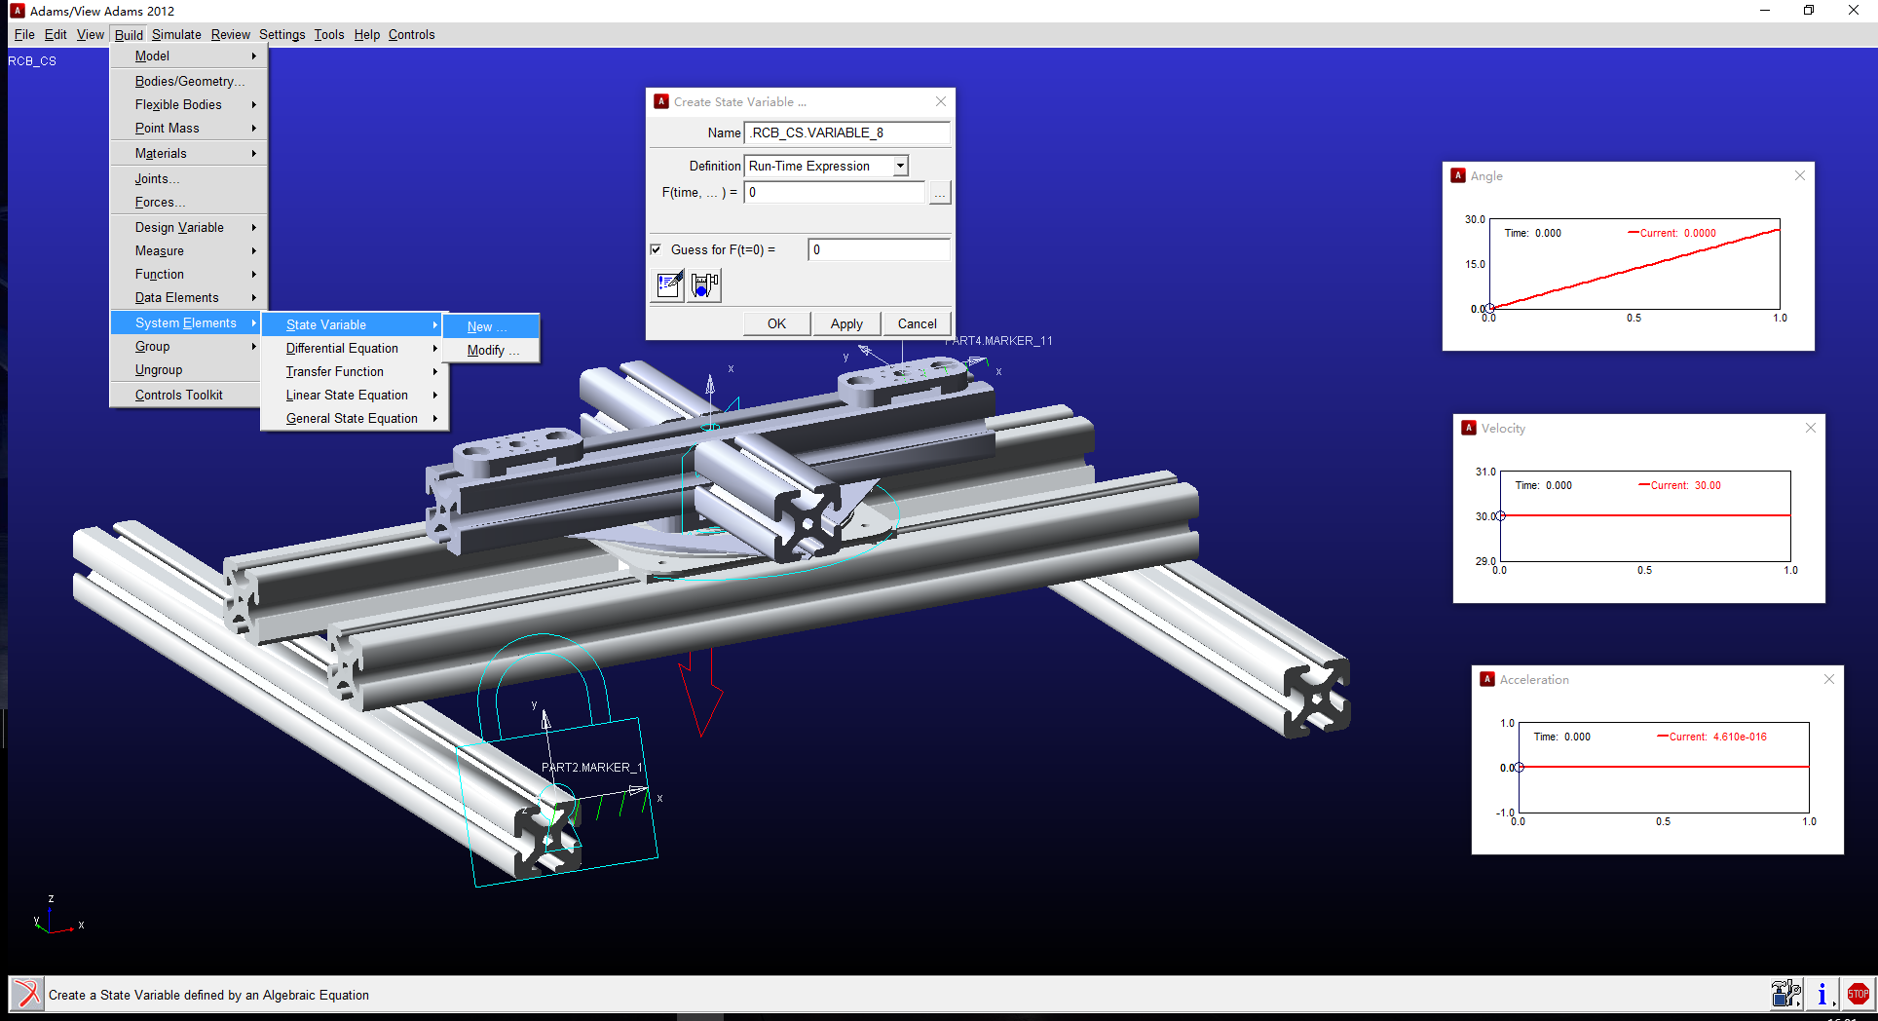

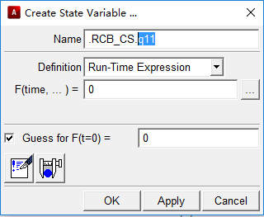

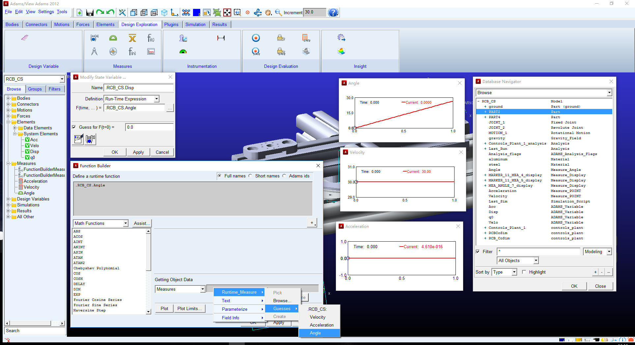

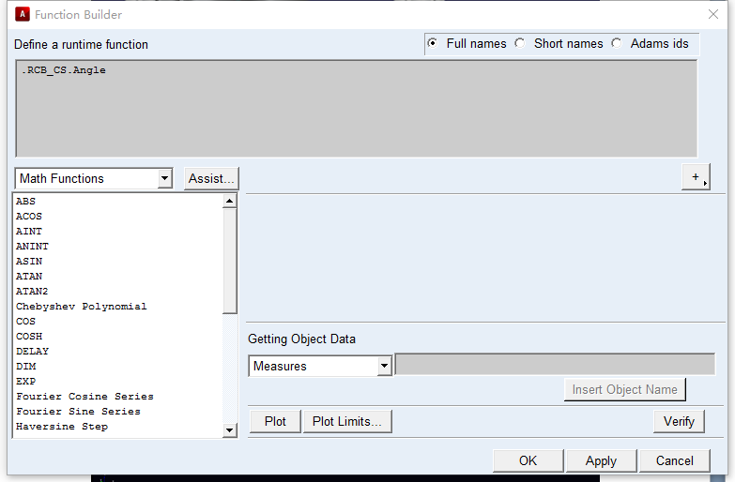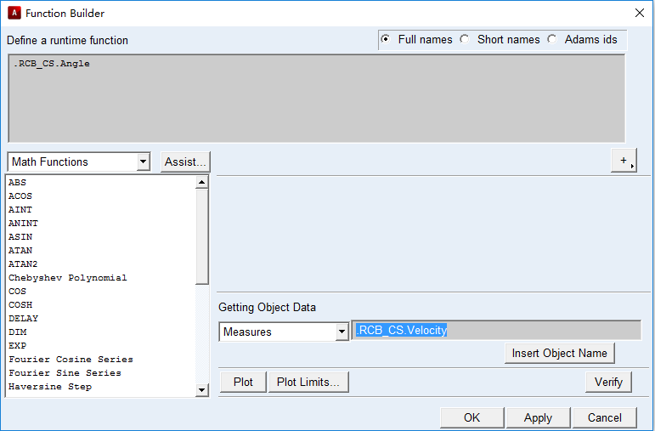

*Step 3: Build ‘***ADAMS/Control***’*

a. Select ‘**Plugin Manager** – **ADAMS/Control** – **Yes** - **OK**’;

b. Name ‘**Control_Plant_1**’ as you wish;

c. Select Input Variables in ‘**Input Signal(s)**’ and ‘**Output Signal(s)**’;

d. Choose ‘**Target Software – Matlab - OK**’;

e. System will **generate corresponding files** in the default directory;

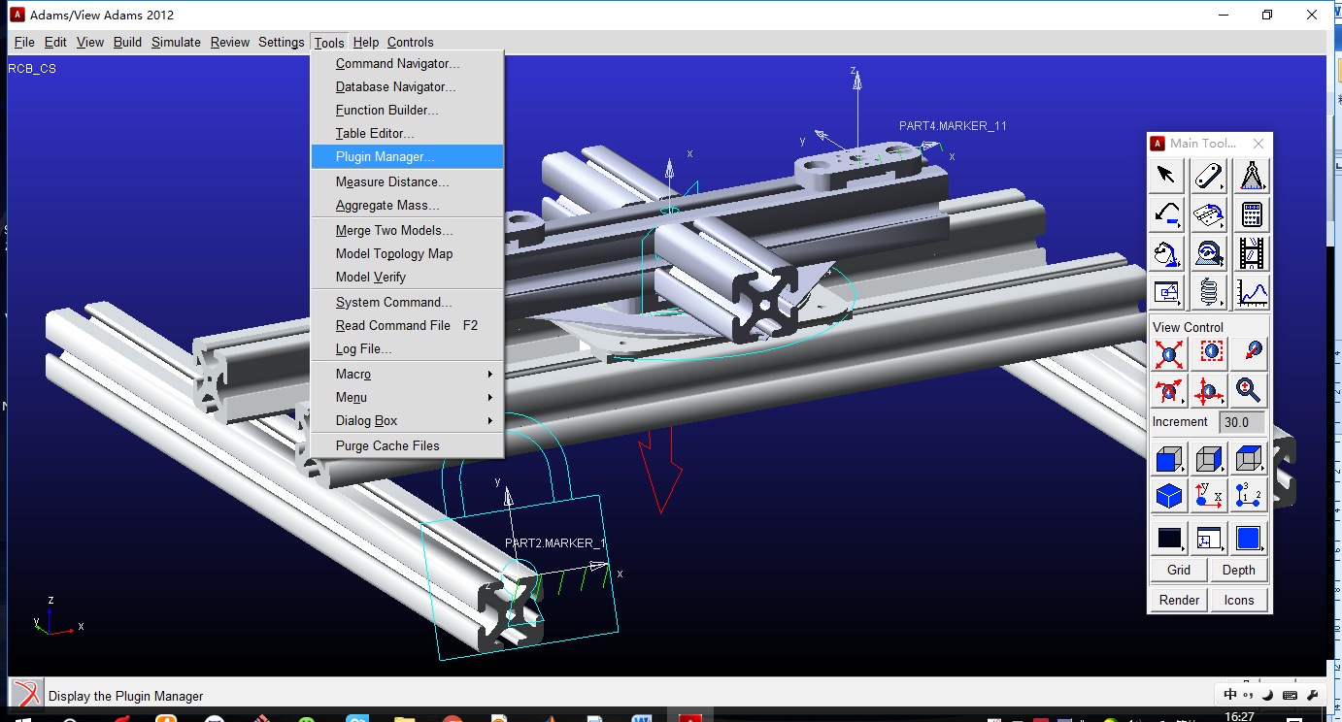

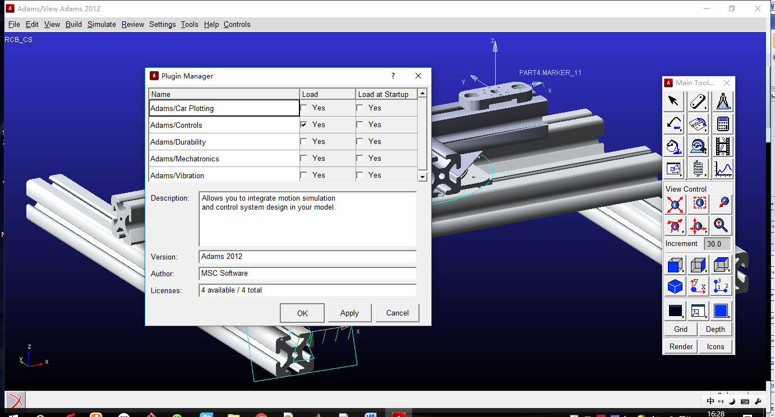

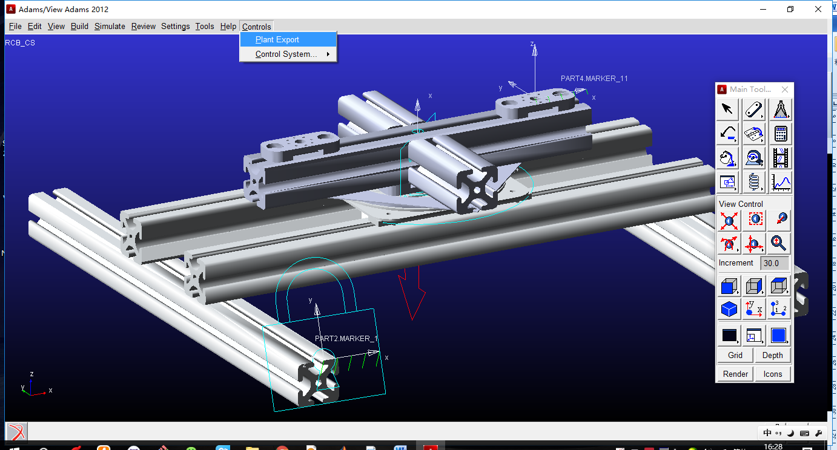

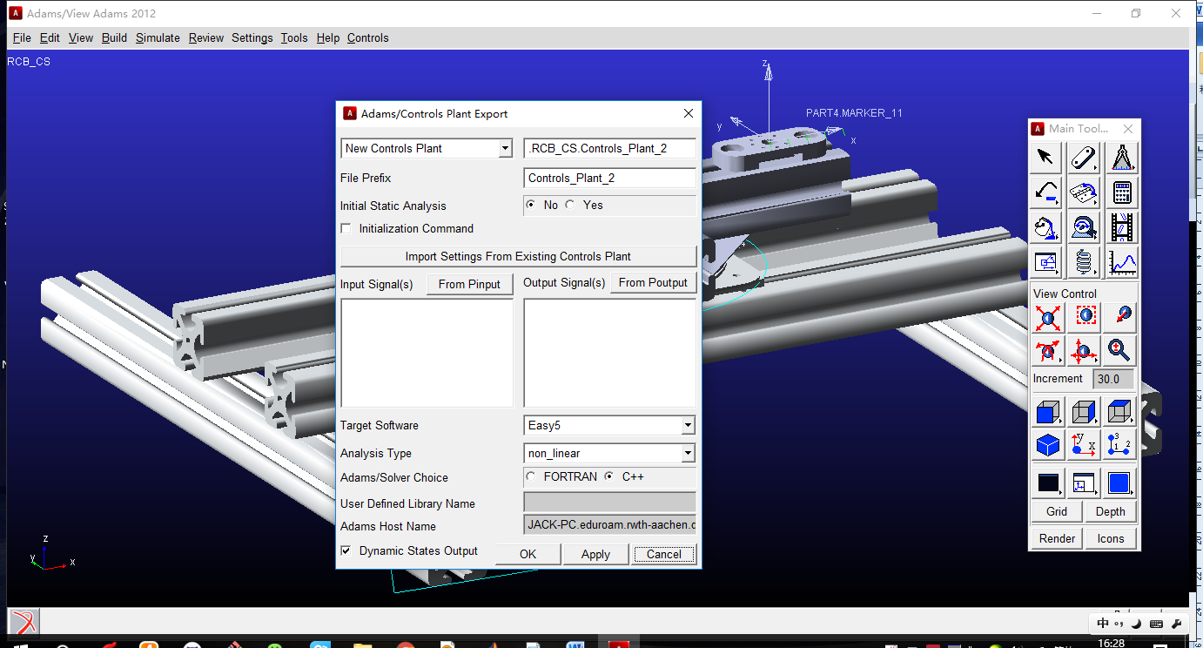

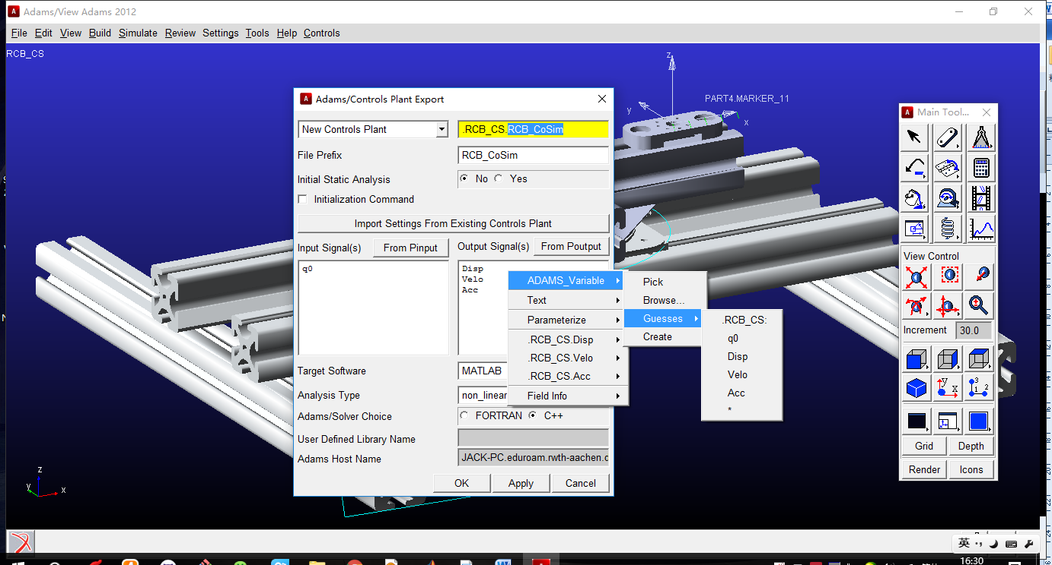

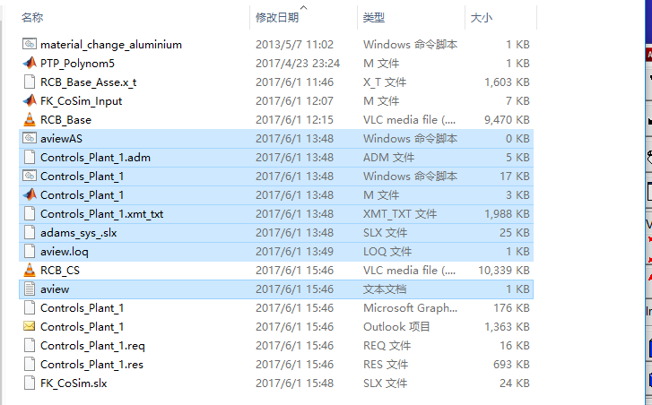

**Part II. Procedure in Matlab**

*Step1: Calculate your variable value in Matlab ‘.m’ file;*

a. Calculate the input variable value first by using your own file, it could be a time based vector or Matrix, which is used for inputs;

(Of course, you can also build Simulink block, such as, Sine/Cosine, etc., as inputs.)

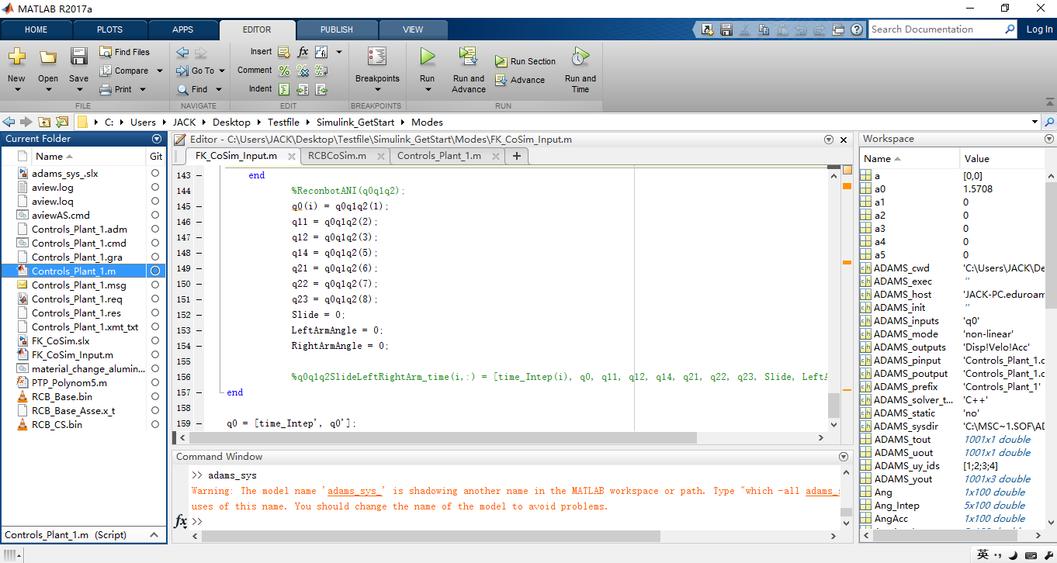

*Step2: Run ‘***Controls_Plant_1.m***’ file that ADAMS generated to build connection*

a. Run ’**Controls_Plant_1.m**’ file;

b. Type ‘**adams_sys**’ in Command Window, you will get the following Simulink window;

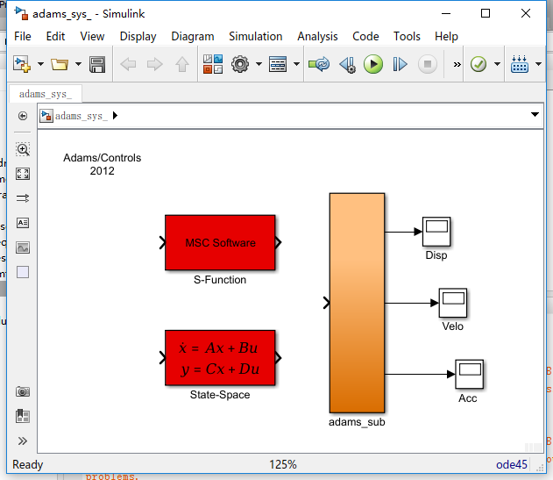

*Step3: Build your own time-based Simulink model*

1) Type ‘**adams_sys**’

2) Copy ‘**adams_sub** ’ to your model

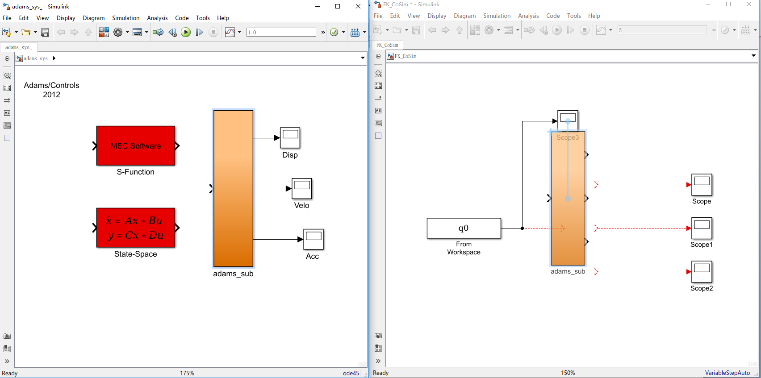

3) Construct your Simulink model

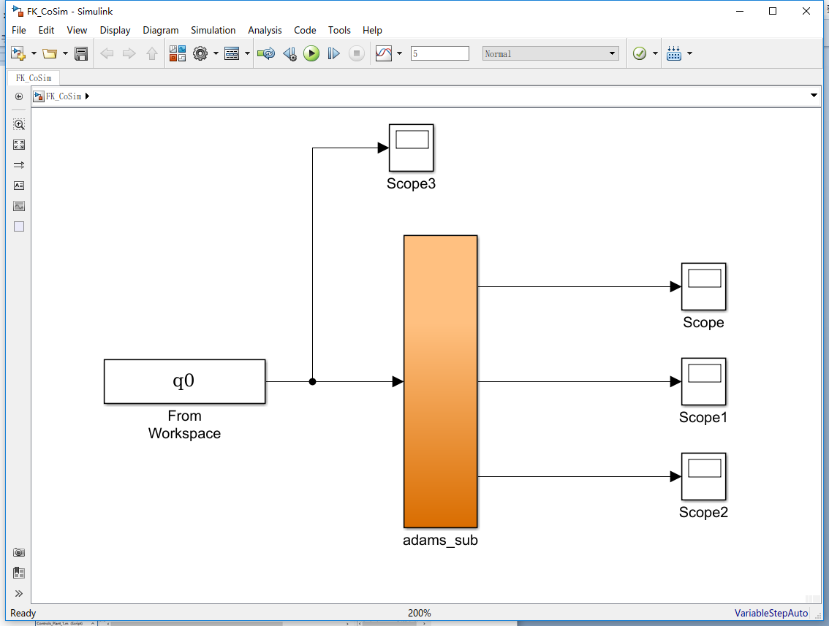

*Step4: Set* **‘MSC.software’** *in ‘***adams_sub***’*

a. Only need to set ‘**Animation Mode - Iterative**’;

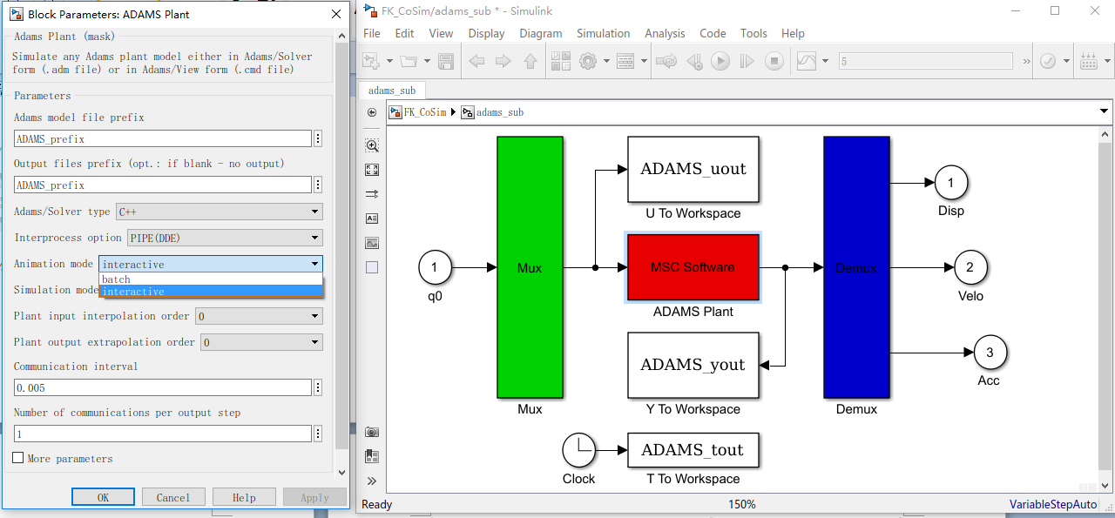

*Step5: Go back to home page of your Simulink model, and set an appropriate simulation time;*

a. Run simulation with appropriate time

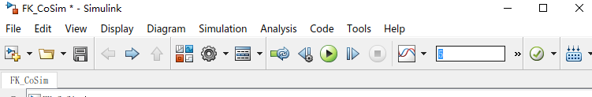

b. the Co-Simulation will launch the ADAMS to proceed the calculation

**Co-Simulation is launched:**

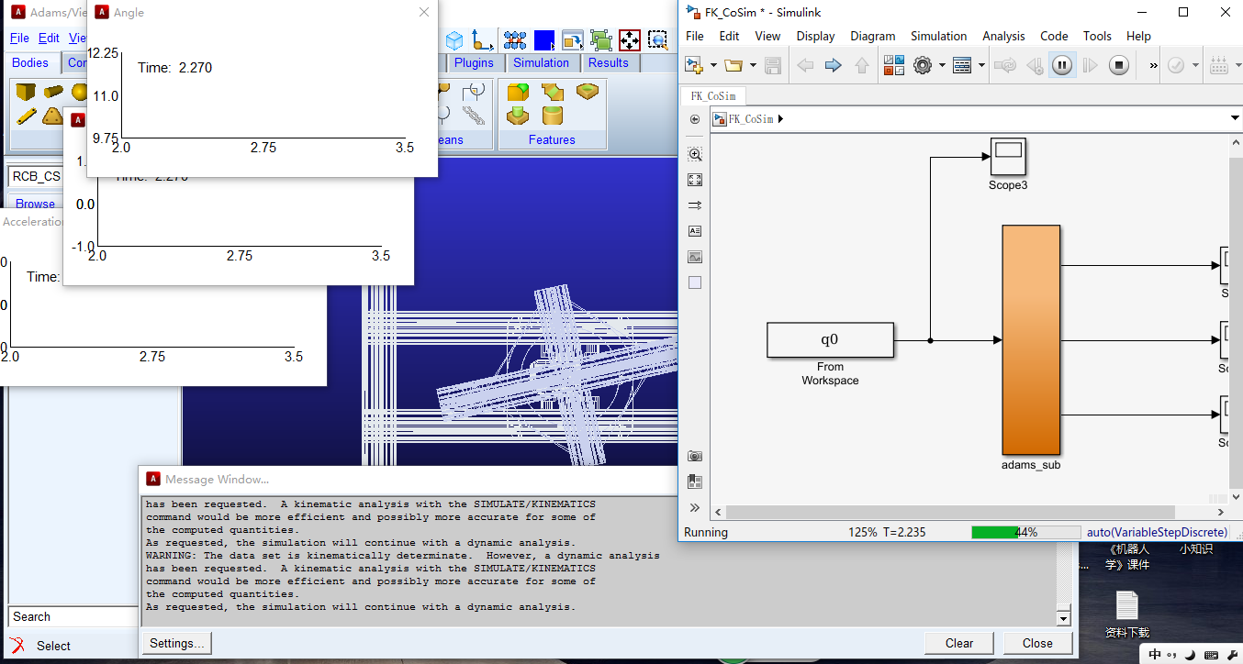

**NOTE:**

As my case for example, the input is a 1X100 vector with each step assigned with time; I use ‘**From Workspace**’ block that can send the vector value of each step to the ‘**adams_sub**’, see the following example, if I have 10 variables with 10X100 matrix.

My Solution:

a. Set a time-based Martix in ‘**From Workspace**’: ‘q0q1q2SlideLeftRightArm_time.mat’;

With the first column is Time, then followed with each variable column;

b. Distribute 10 variables by using ‘**Demux**’

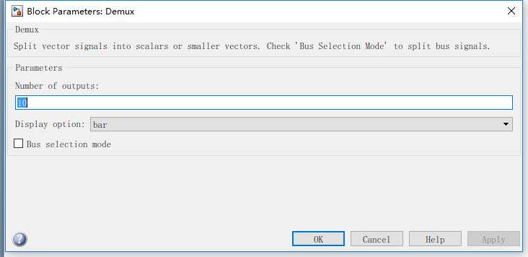

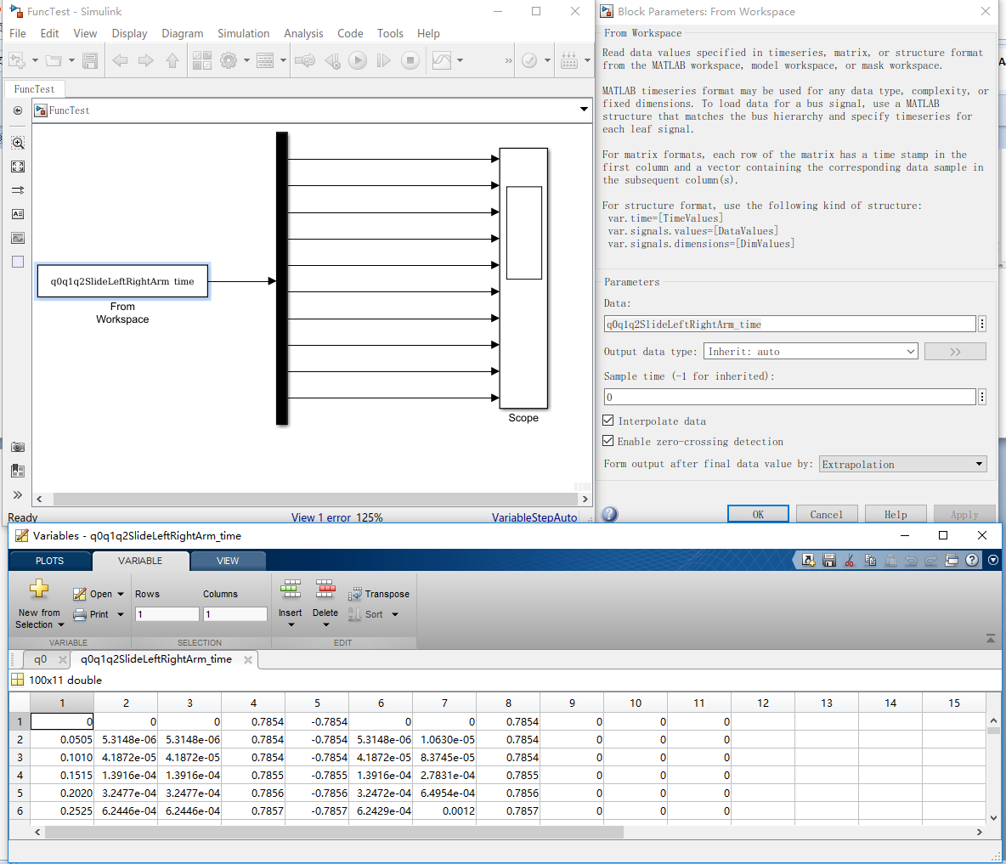

**Part III. Import simulation result in ADAMS**

After running your co-simulation, you can load your calculation results into ADAMS which located in your default directory, and then, you can see the results;

